PHENIKAA UNIVERSITY
PHENIKAA SCHOOL OF COMPUTING
⸎⸎⸎⸎⸎
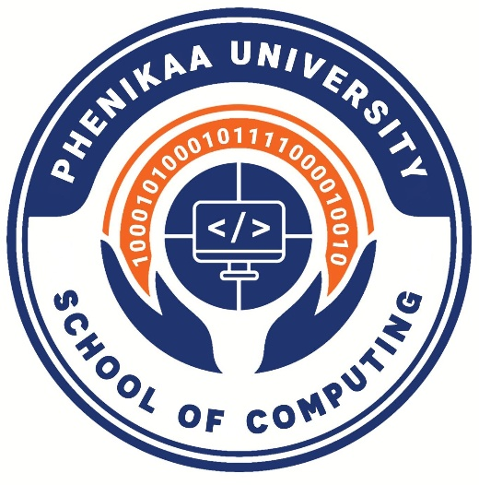

LAB REPORT – LAB 7: EVENT-DRIVEN ARCHITECTURE (EDA) & INTEGRATION
Topic: Building a Web-Based Library Management System
Team : Group 1
Student : Nguyễn Đăng Hiếu – 23010049
Nguyễn Trường Sơn – 23010313
Đỗ Hữu Đại 23010825
Bùi Đắc Hợp 23012022
Instructors : Vũ Quang Dũng
Class : Software Architecture(N01)

Hanoi 24 January 2026

1. Abstract / Summary
This lab focuses on applying Event-Driven Architecture (EDA) in a Library Management System to support asynchronous communication between system components. The main goal is to demonstrate how services can be decoupled using a message broker (RabbitMQ).
In the proposed scenario, when a reader borrows a book, the Borrowing Service publishes a BookBorrowedEvent to the message broker. The Notification Service subscribes to this event and processes it asynchronously to send a confirmation notification to the reader. This approach improves system scalability, reliability, and maintainability while avoiding tight coupling between services.

2. Lab Specific Section: Event-Driven Architecture Overview
Event-Driven Architecture is a software design pattern in which components communicate through events rather than direct service calls. Producers generate events when significant actions occur, while consumers react to those events independently.
In the Library Management System, the event-driven model ensures that the borrowing workflow is not blocked by notification processing. This design is especially suitable for distributed systems where responsiveness and extensibility are critical.

3. Activity Practice 1: Message Broker Setup

Objective
To install and configure RabbitMQ as the message broker for asynchronous communication.

Description
RabbitMQ is deployed locally using Docker. It is responsible for receiving events from producers and delivering them to consumers in a reliable manner.

Configuration Details
- Message Broker: RabbitMQ
- Host: localhost
- Port: 5672
- Queue Name: library_events
This setup ensures that all borrowing-related events are safely stored and forwarded even if the consumer service is temporarily unavailable.

4. Activity Practice 2: Borrowing Service (Event Producer)

Objective
To implement the Borrowing Service as an event producer that publishes events when a book is borrowed.

Description
The Borrowing Service simulates the core functionality of the library system. When a reader borrows a book, the service publishes a BookBorrowedEvent to the RabbitMQ queue. The event contains essential information such as the book details and reader contact information.
The service completes its task immediately after publishing the event, without waiting for any notification processing.

5. Activity Practice 3: Notification Service (Event Consumer)

Objective
To implement the Notification Service as an event consumer that listens for borrowing events.

Description
The Notification Service continuously monitors the library_events queue. Upon receiving a BookBorrowedEvent, it processes the event and simulates sending a confirmation email to the reader.
After successful processing, the service acknowledges the event to the message broker, ensuring reliable event handling and preventing message duplication.

6. Activity Practice 4: Asynchronous Communication Demonstration

Objective
To demonstrate the decoupled and asynchronous behavior of the system.

Observation
- The Borrowing Service publishes events quickly.
- The Notification Service processes events independently and may take longer to complete.
- The Borrowing Service is not affected by the processing time of the Notification Service.

Result
This experiment confirms that the two services are loosely coupled and that the system supports non-blocking, asynchronous execution.

7. Architectural Benefits for Library Management System
Applying Event-Driven Architecture to the Library Management System provides several advantages:
- Scalability: Multiple consumers (email, SMS, mobile notifications) can be added easily.
- Reliability: Events are preserved in the queue until they are processed.
- Maintainability: Business logic is separated across services with clear responsibilities.
- Extensibility: New features can be integrated without modifying existing services.

8. Conclusion & Reflection
This lab demonstrates the effectiveness of Event-Driven Architecture in a Library Management System. By using RabbitMQ to decouple the Borrowing Service from the Notification Service, the system achieves improved scalability, reliability, and flexibility.
The experiment highlights how asynchronous event-based communication is a practical architectural approach for modern distributed systems, particularly in real-world applications such as library management platforms.

